1. What is lift and why is it important in Association rules?

**What is Lift?**

In the context of association rules, **lift** measures the increase in the probability of the consequent given the antecedent compared to the probability of the consequent occurring independently. In simpler terms, it quantifies how much more likely the consequent is to occur when the antecedent is present, compared to the likelihood of the consequent occurring without the antecedent.

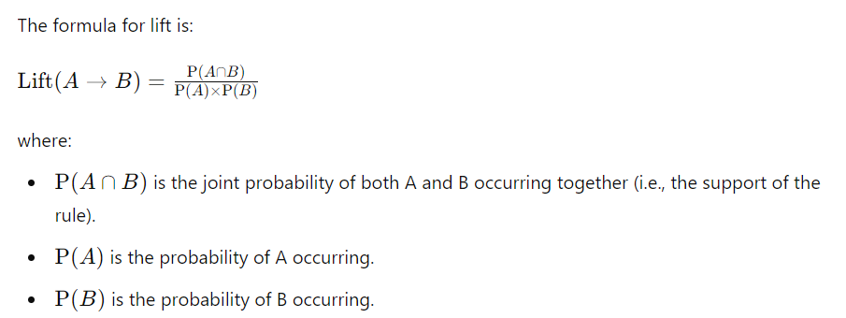

**Why is Lift Important?**

* **Evaluates Rule Strength:** Lift helps determine how strong and interesting an association rule is. A lift value greater than 1 suggests that the antecedent and consequent occur together more often than would be expected by chance, indicating a strong association. Conversely, a lift value less than 1 suggests a weaker or even negative association.
* **Indicates Useful Associations:** Lift provides a way to filter out rules that might appear frequent but are not particularly useful. For example, two items might frequently occur together due to high general occurrence, but a high lift value indicates a specific, useful association.
* **Improves Decision Making:** By using lift, businesses and analysts can focus on rules that are not just frequent but also impactful. This is particularly useful in market basket analysis, where understanding the strength of associations between products can guide promotions, product placement, and inventory management.
* **Contextual Insights:** Lift gives context to the frequency of rule occurrence by accounting for the baseline probability of the items involved. This helps in distinguishing between rules that are simply frequent and those that exhibit a strong relationship.

1. **What is support and Confidence. How do you calculate them?**

**1. Support**

**Support** measures how frequently an itemset (a combination of items) appears in the dataset. In the context of association rules, it reflects the proportion of transactions that contain a particular itemset.

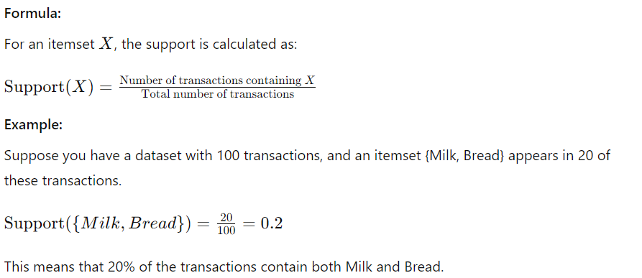

**2. Confidence**

**Confidence** measures the likelihood that the consequent of a rule is present given that the antecedent is present. It is an indicator of how often the rule is true.

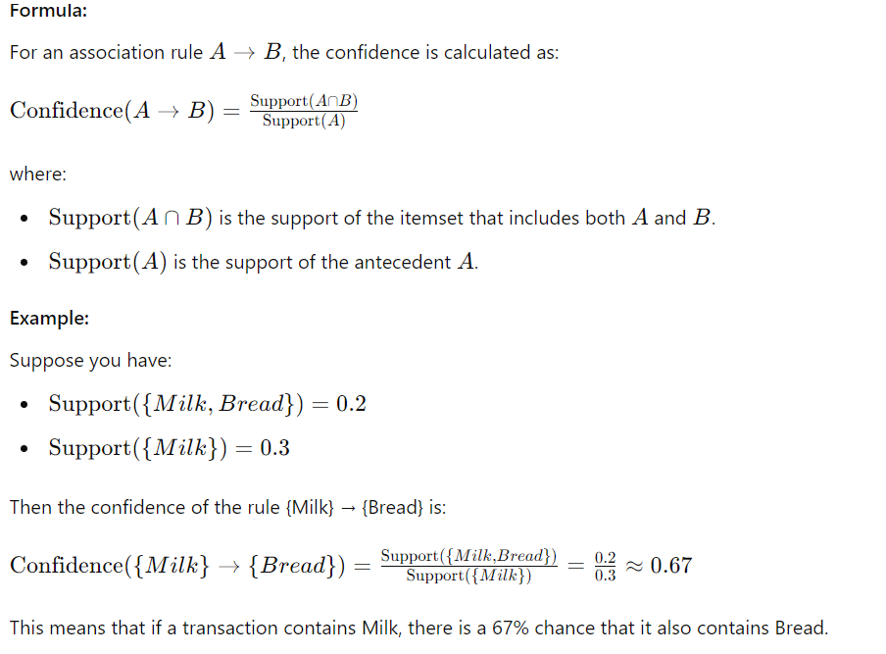

1. **What are some limitations or challenges of Association rules mining?**

### 1. ****Scalability****

**Challenge:** Association rule mining can become computationally expensive as the size of the dataset and the number of items increase. The number of possible itemsets grows exponentially, which can lead to high computational and memory requirements.

**Impact:** Large datasets with many items may result in a very large number of potential rules, making it challenging to process and analyze them efficiently.

**Solution:** Techniques like sampling, reducing the dimensionality of the data, or using more scalable algorithms (e.g., FP-Growth instead of Apriori) can help manage scalability issues.

### 2. ****High Dimensionality****

**Challenge:** Datasets with a large number of items can lead to a combinatorial explosion of possible itemsets and rules.

**Impact:** High dimensionality can make it difficult to find meaningful rules and can result in a large number of rules that are not practically useful.

**Solution:** Applying dimensionality reduction techniques, setting appropriate support and confidence thresholds, and using domain knowledge to filter out less relevant items can mitigate this issue.

### 3. ****Overfitting****

**Challenge:** There is a risk of generating too many rules that fit the training data but do not generalize well to new data.

**Impact:** Rules may capture noise or peculiarities in the training data rather than true, generalizable patterns, leading to overfitting.

**Solution:** Cross-validation techniques and evaluating rules on separate validation datasets can help in assessing their generalizability and robustness.

### 4. ****Lack of Temporal Dynamics****

**Challenge:** Association rule mining typically does not account for temporal aspects or changes over time.

**Impact:** In dynamic environments where item relationships change over time, static rules might become obsolete or less relevant.

**Solution:** Incorporate temporal data analysis and dynamic association rule mining methods that consider time-related factors.

### 5. ****Interpreting Rules****

**Challenge:** The large number of rules generated can be overwhelming, and distinguishing between meaningful and trivial rules can be difficult.

**Impact:** Users may struggle to extract actionable insights from the vast number of rules, and there is a risk of focusing on less relevant rules.

**Solution:** Use measures like lift, support, and confidence to filter and prioritize rules, and employ techniques for rule clustering or summarization to manage and interpret rules effectively.

### 6. ****Data Quality****

**Challenge:** Poor-quality data, including noise, missing values, and inconsistencies, can affect the results of association rule mining.

**Impact:** The rules generated may be misleading or incorrect if the input data is unreliable.

**Solution:** Preprocess and clean the data to ensure quality before applying association rule mining. Handle missing values and remove outliers to improve the robustness of the results.

### 7. ****Interpretability of Complex Rules****

**Challenge:** As the complexity of rules increases (e.g., involving many items or multiple itemsets), the rules can become difficult to interpret.

**Impact:** Complex rules may be harder to understand and apply in practical scenarios, reducing their utility for decision-making.

**Solution:** Focus on simpler, more actionable rules, and consider using rule reduction techniques to simplify complex rules while preserving their relevance.

### 8. ****Choice of Parameters****

**Challenge:** The effectiveness of association rule mining depends heavily on parameter settings like minimum support and confidence thresholds.

**Impact:** Incorrectly chosen parameters can lead to either too many rules (with low support and confidence) or too few (with very high thresholds), which can miss important relationships.

**Solution:** Experiment with different parameter settings and use domain knowledge to choose appropriate thresholds. Employ parameter tuning techniques to find optimal values.